Sample activities you can use as part of Summer Reading Program for young children

Gameboard can say “Do a Smart Start Activity” and the adult would choose from these. This is just a sampling; you can think of more. Include all six skills: Print Motivation, Phonological Awareness, Vocabulary, Narrative Skills, Print Awareness, and Letter Knowledge.
These six skills are from ALA’s Every Child Ready to Read @ your library® (www.ala.org/everychild)

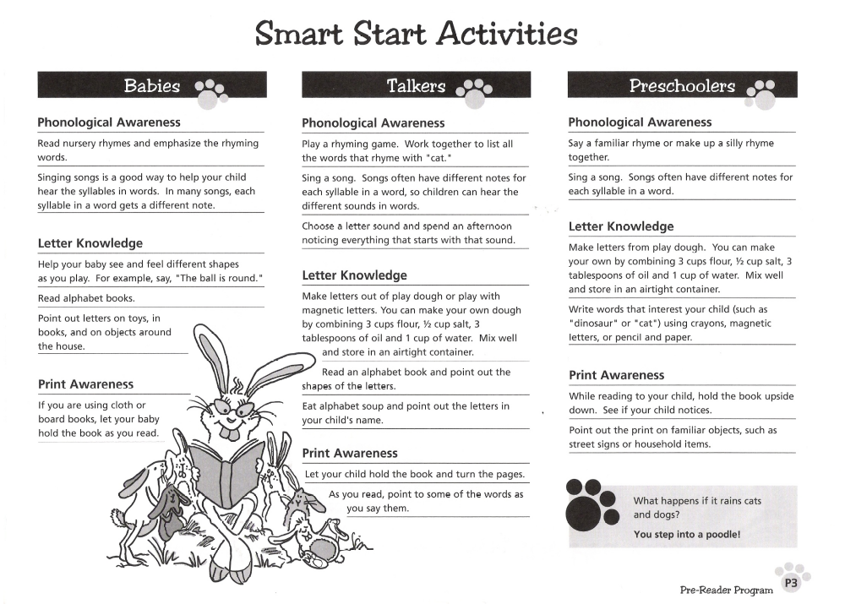
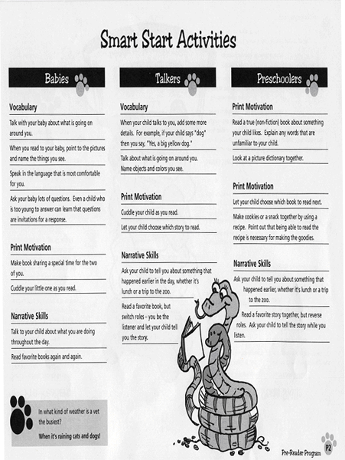
Allen County Public Libraries
Fort Wayne, Indiana

