Even from birth we can develop children’s abstract thinking, the basis for science concepts by:

* Following your child’s lead, their interests
* Giving children time to figure things out
* Putting words to what they are looking at or playing with, adding descriptions
* Encouraging persistence and problem solving
* Using words for science concepts

**Building on Children’s Curiosity:**

**Talking with Children to Support Science Thinking**

Even from birth we can develop children’s abstract thinking, the basis for math concepts by:

* Following your child’s lead, their interests
* Giving children time to figure things out
* Putting words to what they are looking at or playing with, adding descriptions
* Encouraging persistence and problem solving
* Using words for math concepts

**Building on Children’s Curiosity:**

**Talking with Children to Support Math Thinking**

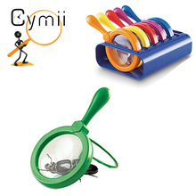

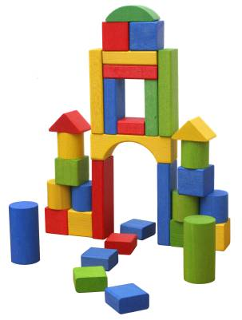

**Science Concepts**

**Math Concepts**

**Math Content**

**Numbers and Operations**—counting, connects numerals with number, cardinal (1,2,3) and ordinal (1st, 2nd, 3rd)

**Patterns, Relationships, Functions**—notices and makes repeating patterns, sorts by characteristics (size, color, shape), matching items

**Geometry and Spatial Relationships**—recognizes and names shapes, two and three-dimensional (circle, sphere), spatial relationships (above, below, between, behind, etc.)

**Comparison and Measurement**—compares such as more, less, measures both standard and non-standard—inches, pounds, and handful

**Time and Sequence**—developing concept of time especially daily routines, putting events in order

**Math Process**

**Problem Solving—**estimating, guessing, tries different possibilities, is persistent, flexible thinking

**Representation—**uses pictures and graphs to show math concepts

**Communication—**uses math words

**Making connections—**applies math to different situations, such as when figuring out when something

is fair or not

**General Science Content**

**Life science**—living things and their characteristics

**Physical science**—knowledge of physical properties of objects and materials (heavy, light, float, sink)

**Earth and space science**—knowledge of earth’s environment, solar system, seasons, weather

**Tools**—Knowing names of tools and what they do, using tools and technology to perform tasks and investigate.

A tool is a device or utensil that helps in accomplishing a task.

**Science Process Skills**

When we give children the chance to practice the skills listed below, we are helping to develop basic scientific thinking.

• **Observing**—using senses to observe and explore

materials and world around him/her

• **Asking** questions—wondering

• **Describing** objects, what is happening, what they are

doing

• **Predicting** what might happen

• **Experimenting—**planning and engagingin “what if”

investigations

• **Gathering** information from investigations

• **Recording** what happens during these investigations

• **Concluding**—connecting and interpreting the

information collected

• **Communicating** and sharing ideas using science

language and ideas

www.earlylit.net