**Keep on having fun with math**

**Building on Children’s Curiosity:**

**Talking with Children to Support Math Thinking**

**In today’s storytime,** we talked about the math concept, spatial relationships.

Helping children understand concepts like over, under, between, above, on, in below, on top of, behind, in front of, next to, beside, left, right, develop this math concept.

Even from birth we can develop children’s abstract thinking, the basis for math concepts by:

* Following your child’s lead, their interests
* Giving children time to figure things out
* Putting words to what they are looking at or playing with, adding descriptions
* Encouraging persistence and problem solving
* Using words for math concepts

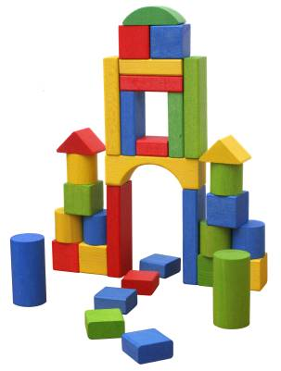

In today’s storytime, the children took turns putting up a circle. Then we described its position. The circle is between the two triangles.

**Math Concepts**

**Math Content**

**Numbers and Operations**—counting, connects numerals with number, cardinal (1,2,3) and ordinal

(1st, 2nd, 3rd)

**Patterns, Relationships, Functions**—notices and makes repeating patterns, sorts by characteristics (size, color, shape), matching items

**Geometry and Spatial Relationships**—recognizes and names shapes, two and three-dimensional (circle, sphere), spatial relationships (above, below, between, behind, etc.)

**Comparison and Measurement**—compares such as more, less, measures both standard and non-standard—inches, pounds, and handful

**Time and Sequence**—developing concept of time especially daily routines, putting events in order

**Math Process Skills**

**Problem Solving—**estimating, guessing, tries different possibilities, is persistent, flexible thinking

**Representation—**uses pictures and graphs to show math concepts

**Communication—**uses math words

**Making Connections—**applies math to different situations, such as when figuring out when something

is fair or not

**Ways to keep it going:**

You may find opportunities to use words for spatial relationships with your children throughout the day.

When we purposely use the words for spatial relationships and explain what they mean, we are helping our children develop math concepts.

Describe what your child is doing using some of these words

Play a game where you have an object and you describe where your child should put it using words for spatial relationships. Then have our child describe where you should place an object.

Use these words as you clean up, set the table, play hide and seek, put laundry away, play in the bathtub.

When else are you using these words that support math concepts?

www.earlylit.net