***Hooray for Hat* by Brian Won**

**Flannel Board Pieces**

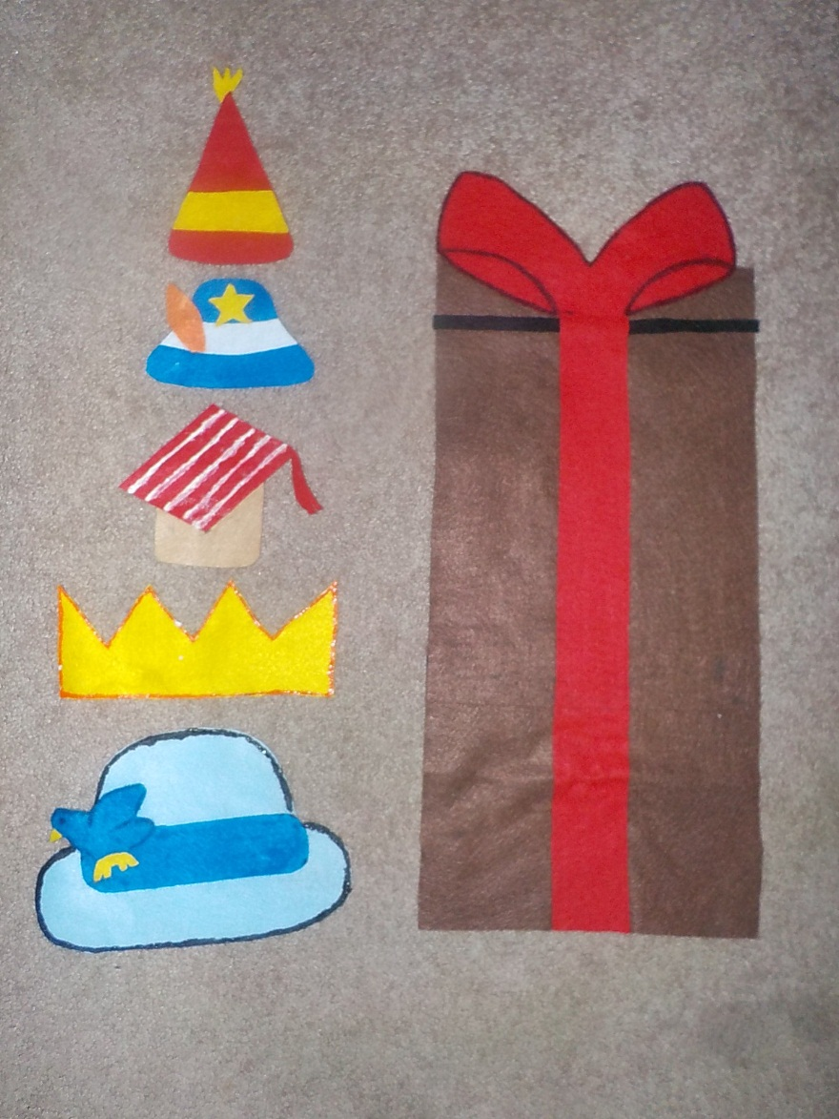

**The grumpy and smiling faces are back to back.**

**Measurements are approximate, to give you an idea. All hats can fit behind the gift box when overlapping slightly.**

**Gift box 16”H x 9”W**

**Bottom blue hat 5.5”H x 8”W**

**Crown 3”H x 7”W**

**Red stripe hat 4.5”H x 5”W**

**Feathered cap 3”H x 4.5”W**

**Triangle hat 5.5”H x 3.5”W**

**Animals:**

**Elephant 9”H x 12”W**

**Zebra 12”H x 8”W**

**Owl 8.5”H x 8”W**

**Turtle 5”H x 8”W**

**Giraffe 12”H x 8.5W at ears, 5.5”W at base**

**Lion 9”H x 10.5”W**

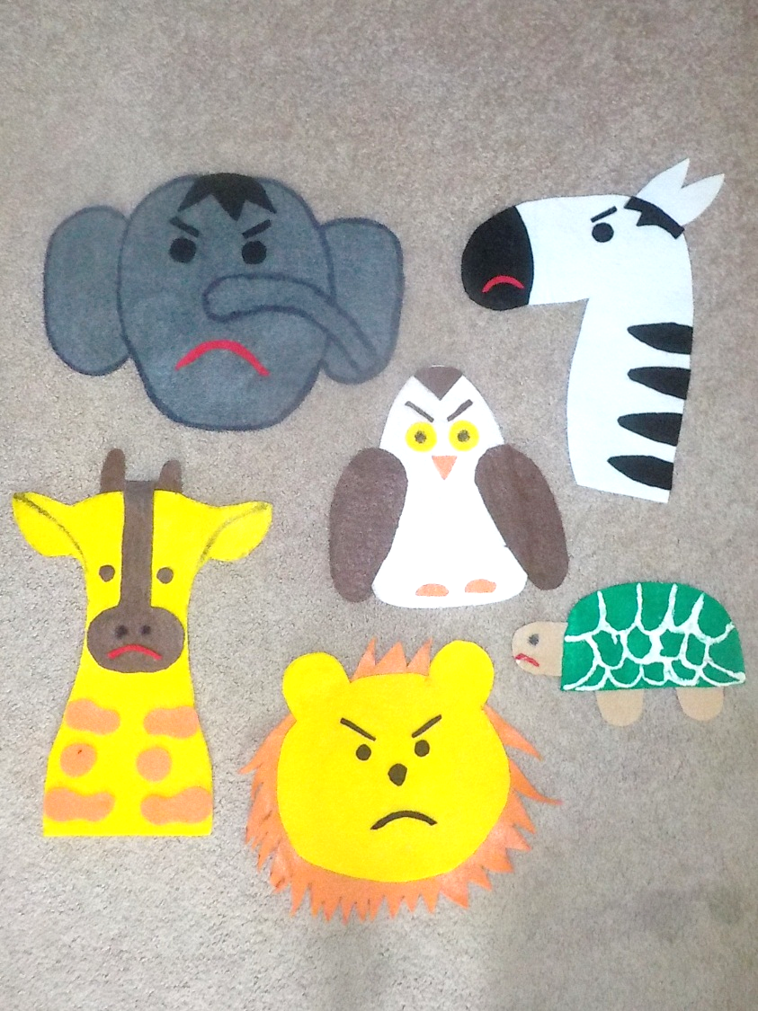

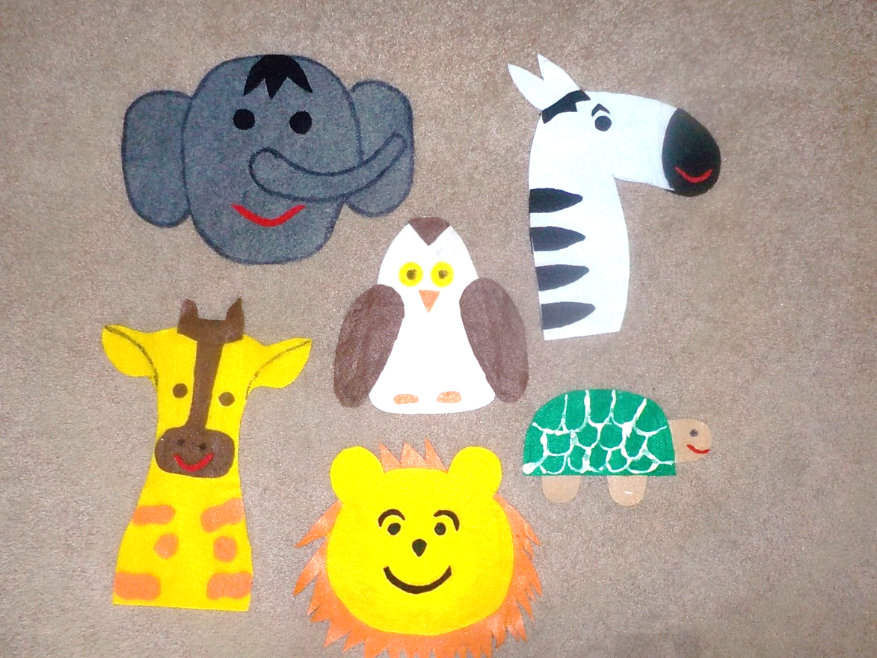

**Saroj Ghoting** [**sghoting@gmail.com**](mailto:sghoting@gmail.com)[**www.earlylit.net**](http://www.earlylit.net)