
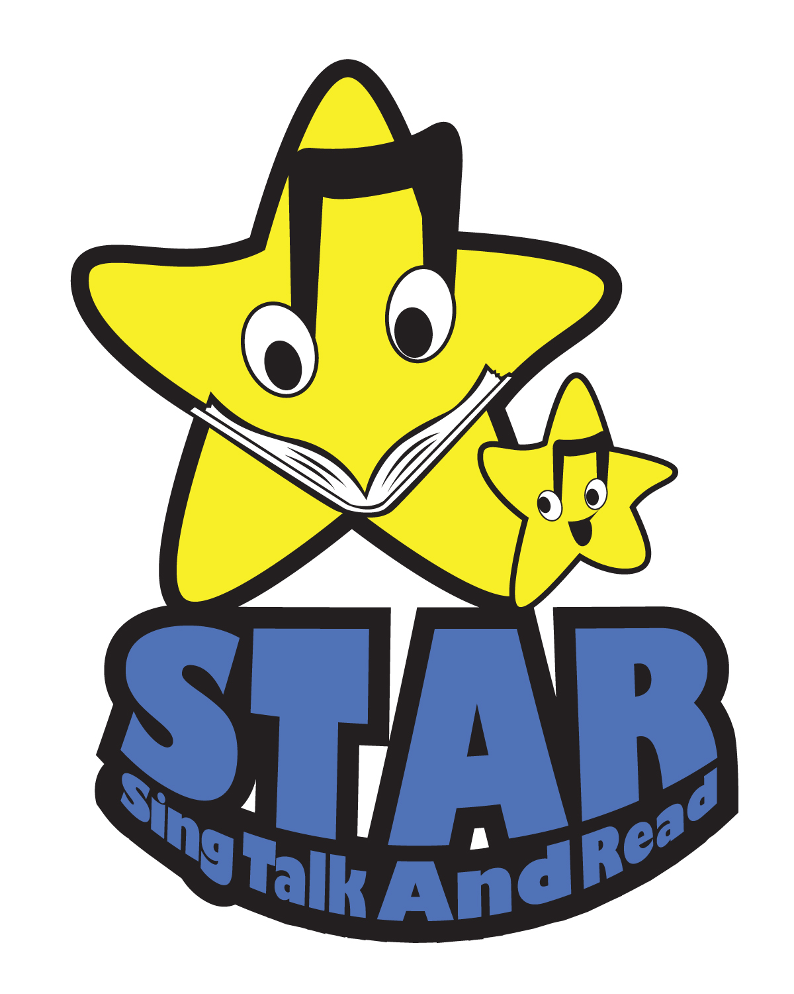

Phonological Awareness

Ability to hear and play with the smaller sounds in words

What You Do, What You Might See

You and Your Preschooler:

- I talk with my child about the sounds we hear all around us.

- We clap out the syllables of words my child likes.

- I say nursery rhymes and sing songs with my child.

- My child and I play music and dance to the rhythm of the music.

- I read rhyming books to my child. I help my child recognize rhyming words by asking him if two words rhyme.

- I help my child learn about rhyming by saying a word and having her think of words that rhyme with it—even nonsense words.

- I help my child hear the beginning sounds of words by emphasizing them. We think of other words that start with the same sound.

- I play word sound games with my child.

- Even if I get tired of singing songs, saying nursery rhymes, talking about rhyming, playing word sound games or reading books over and over again, I still do it because it helps my child learn.

- I visit the library with my child.

(See back for order of sounds in children’s speech.)
Letter Sounds

It is important to do activities with sounds children can say easily. Below is the general order of sounds as they develop in children’s speech.
You do not need to stick to this exact order when you play with sounds with your child.

Try not to choose words with beginning sounds
q, sh, ch and th because the written letters are not the same as the speech sounds. For example the ch in church does not start with the c sound in cat.

Start with these letter-sounds:
W as in water, worm, wet, window
P as in pot, paint, pear, pool
B as in bed, bike, ball, boy
D as in door, doll, dog
T as in toy, truck, tree
M as in mop, mail, milk, man
N as in net, nap, nose
H as in house, hill, horse, head
Y as in yogurt, yard, yellow

Next come these letter-sounds:
F as in fork, fox, fan
V as in violin, van, vase
S as in sock, sun, spoon
Z as in zoo, zipper, zebra
G as in goat, gate, grass
K as in kite, kangaroo, king
C as in cat, cake, cookie, car

Last come these letter-sounds:
J as in juice, jar, jelly
L as in light, lion, leg
R as in rain, rock, rake

In English the same letter can have
more than one sound.
For now, use one sound (as noted above)
for each letter.

STAR for You and Your Preschooler Week 1 Phonological Awareness


