DISCOVERING

while

### **CONVERSATION**

### **STARTERS**

### **toddlers**



together



“I notice

you are wearing two different colored socks.”

**Acknowledges something without judgment**.

# “I wonder

why the car moves faster when   
 it’s going down the ramp.”   
 Pause. If the child can’t say why,   
 describe the slant of the ramp.

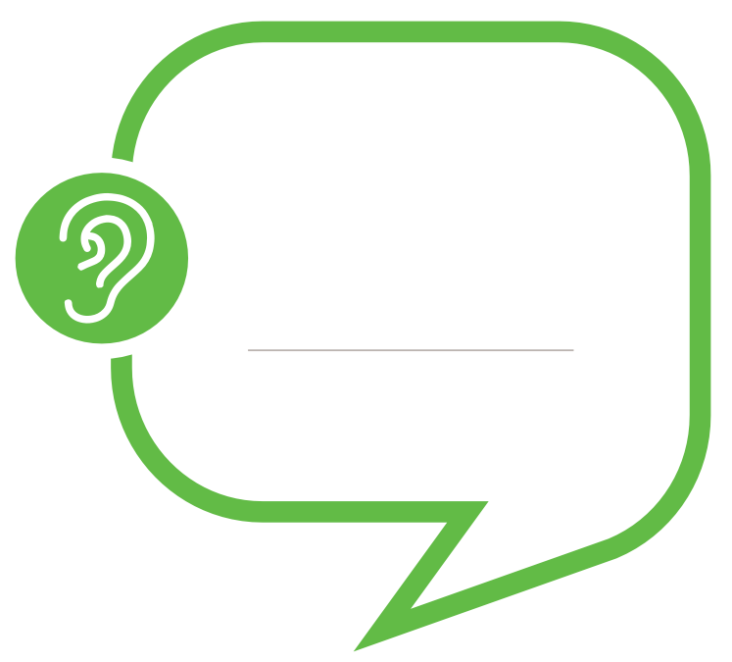

“Tell me about this.”

Pause. If you cannot understand all your child is saying,

say what you notice.

**Encourages children**

**to express their ideas**

**Shows curiosity and a desire to learn more.**

### **CONVERSATION**

### **STARTERS**

### **toddlers**

READING

while

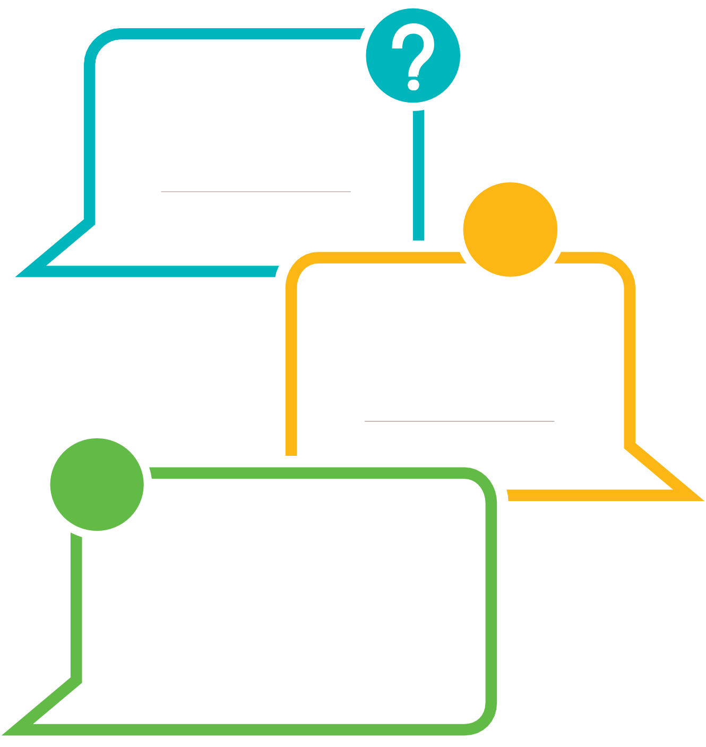

together

“What do you think

is happening here?”

Point to the pictures on a page.

Pause to allow time for child to respond.

**Encourages children to express**

**their ideas.**

“How do you think this character feels?”

Choose a picture of a character that shows emotion. . Pause. If the child does not respond, offer suggestions. Talk about a time when your child

may have felt that way.

**Helps build empathy.**

## **.**

“What do you think will happen next?”

Pause. Child may point to something in the picture or respond verbally.

Repeat the child’s response or provide your own based on child’s gestures.

“Now let’s see what happened in the book.”

**Prompts children to make predictions.**

together

PLAYING

while

### **CONVERSATION**

### **STARTERS**

### **TODDLERS**

“How are these two items   
the same or different?”  
“Let’s see how these two dolls are the same and different.   
What do you think?”   
Also, “How do they look like you?   
How do they look different from you?”

**Asks children to compare and contrast.**

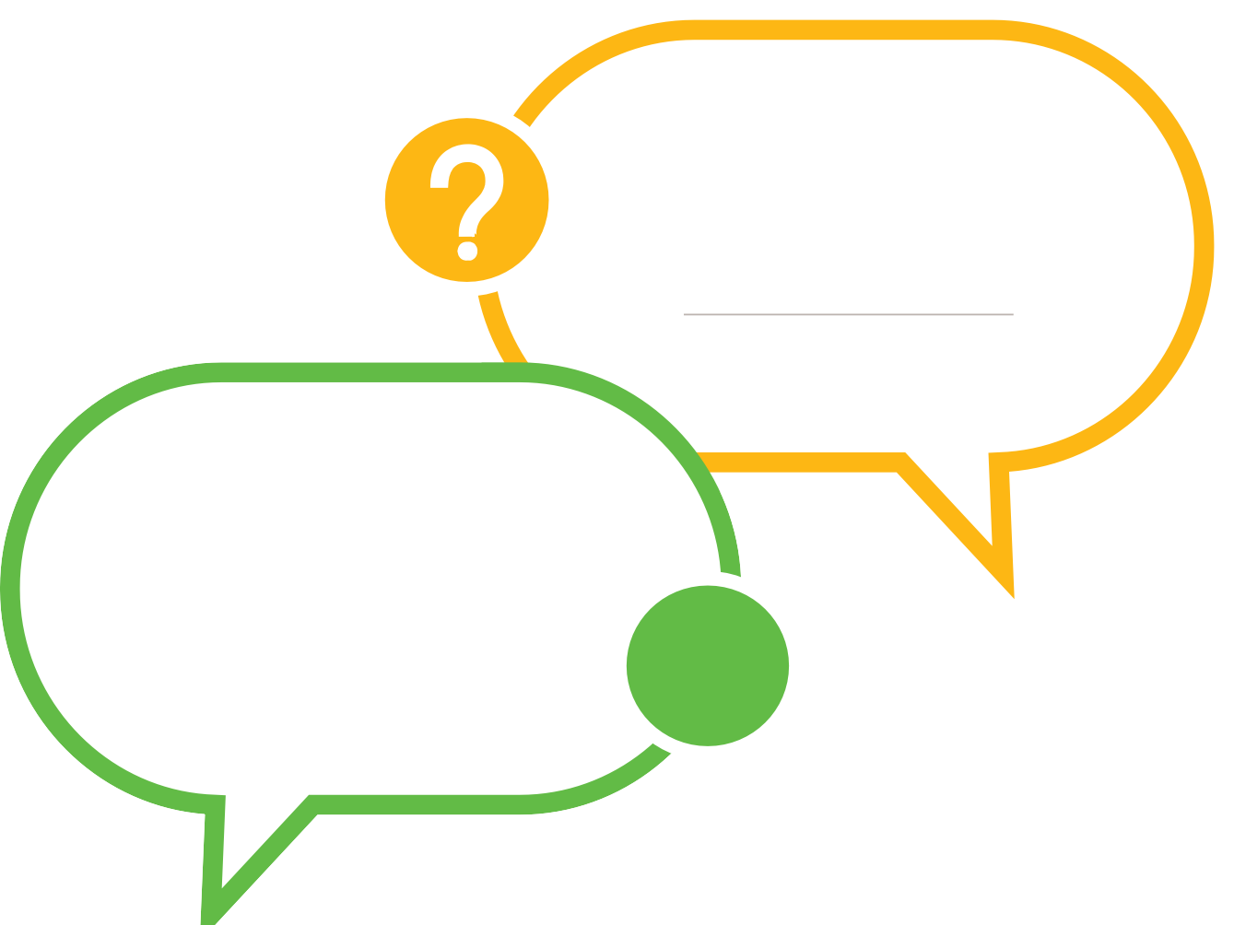

“What can you do

to build a taller tower?”

**Challenges children to improve their work.**

“How can we work together?”

“What would you like me to do?”

**Encourages collaboration.**

### **CONVERSATION STARTERS**

### **TODDLERS**

EXPLORING



“What do you notice

about this leaf?”  
Pause. Offer further description.

**Prompts children to observe closely.**

while

together



“What would happen if

you moved that block to a different spot?”

**Encourages children to consider   
different approaches.**



“Let’ see how we can find out more

about trains.”

**Encourages children to seek out new information.**

while

REFLECTING

together

### **CONVERSATION**

### **STARTERS**

### **toddlers**

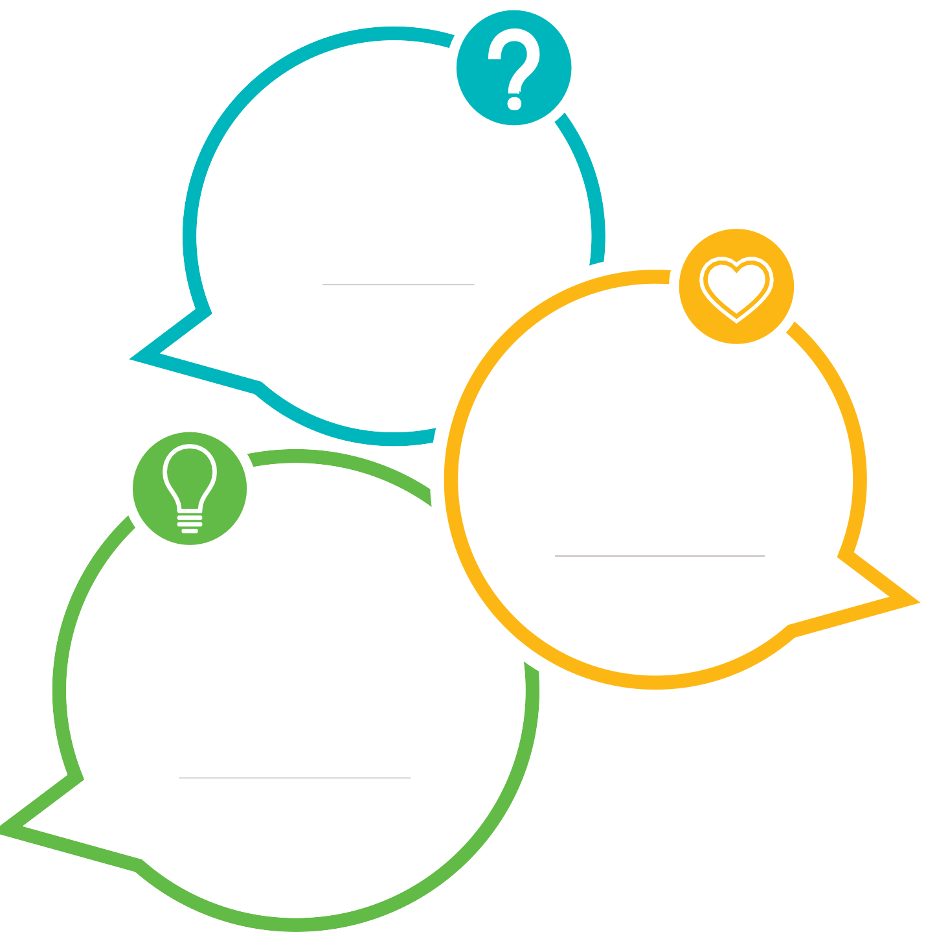

“What was   
easy or hard

for you to do?”

**Asks children to evaluate their skills**.

“What else can

you try?”

“You like to drop that ball from your high chair. Let’s experiment with bouncing   
different kinds of balls.”

**Encourages children to consider different approaches.**

**Focuses attention on emotions.**

“How do you feel about what you did?”

Watch child’s expressions. Acknowledge what child says.

Suggest feeling words based on what you have observed.