DISCOVERING

while

together

### **CONVERSATION STARTERS**

### **Preschoolers**

“I notice

you colored the sky green.”

**Acknowledges something without judgment.**

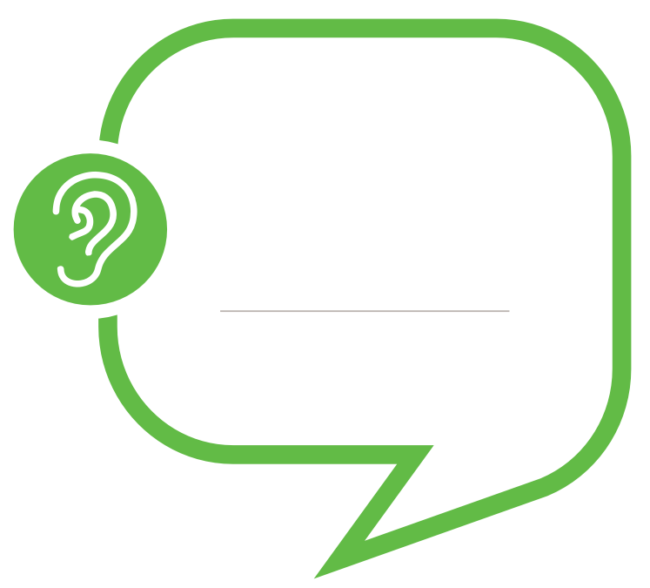

“Tell me more  
about your design.”

**Encourages children**

**to express their ideas.**

“I wonder

how we could make the car move   
more slowly.”

**Shows curiosity and a desire**

**to learn more.**



READING

while

together

### **CONVERSATION**

### **STARTERS**

### **Preschoolers**

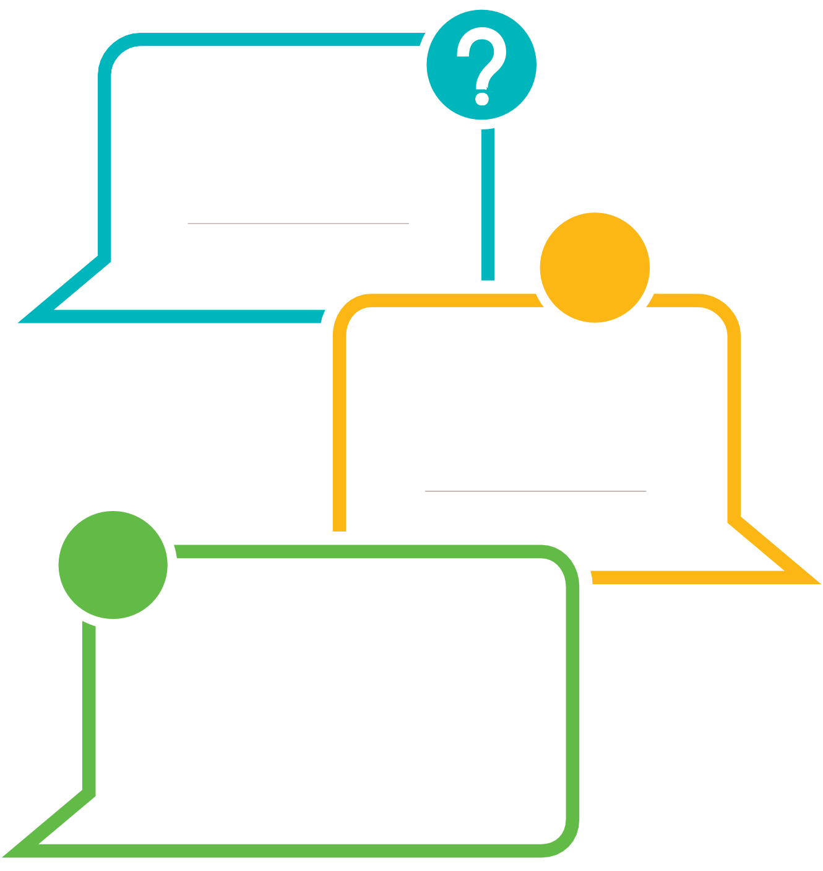

“How would you feel

if you were in that situation?”  
Help the child remember a time they felt that way.

**Helps build empathy.**

“Why do you think

the character did that?”

**Encourages children**

**to explain their ideas.**

“What do you think will happen next?”  
  
Listen to and acknowledge child’s response.  
“Now let’s see what the author chose

to have happen.”

**Prompts children to make predictions.**

PLAYING

while

together

### **CONVERSATION**

### **STARTERS**

### **Preschoolers**

“What’s the   
same and different

about these two tools?” Pause for child’s response.   
“How do they look? What are they used for?”

**Asks children to compare and contrast.**



**.**

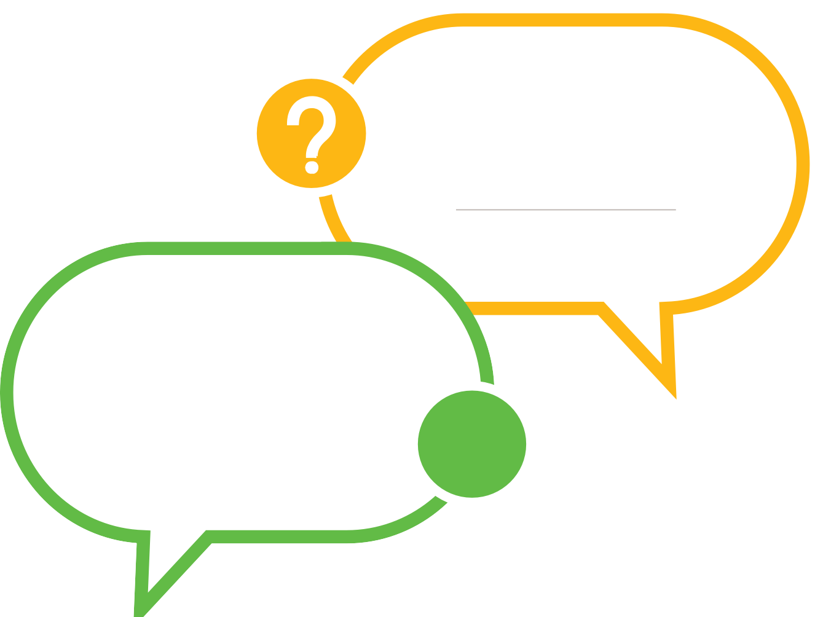

“How can you

make the base of your tower stronger?”

**Challenges children to improve their work.**

“How can we work together?”

“What would you like me to do?”

**Encourages collaboration.**

### **CONVERSATION STARTERS**

### **Preschoolers**

EXPLORING

while

together



“What do   
 you notice

about this leaf?”  
 Expand on what the child observes.

**Prompts children to   
 observe closely.**

## 

“How do you think   
we could

find out more

about trains?” Pause for child’s response.  
“Where do you think we could find out

more information?”

**Asks children to seek out  
new information.**



“What would happen if

we didn’t use any tape next time?”

**Encourages children to consider different approaches.**



### **CONVERSATION STARTERS**

### **Preschoolers**

REFLECTING

while

together

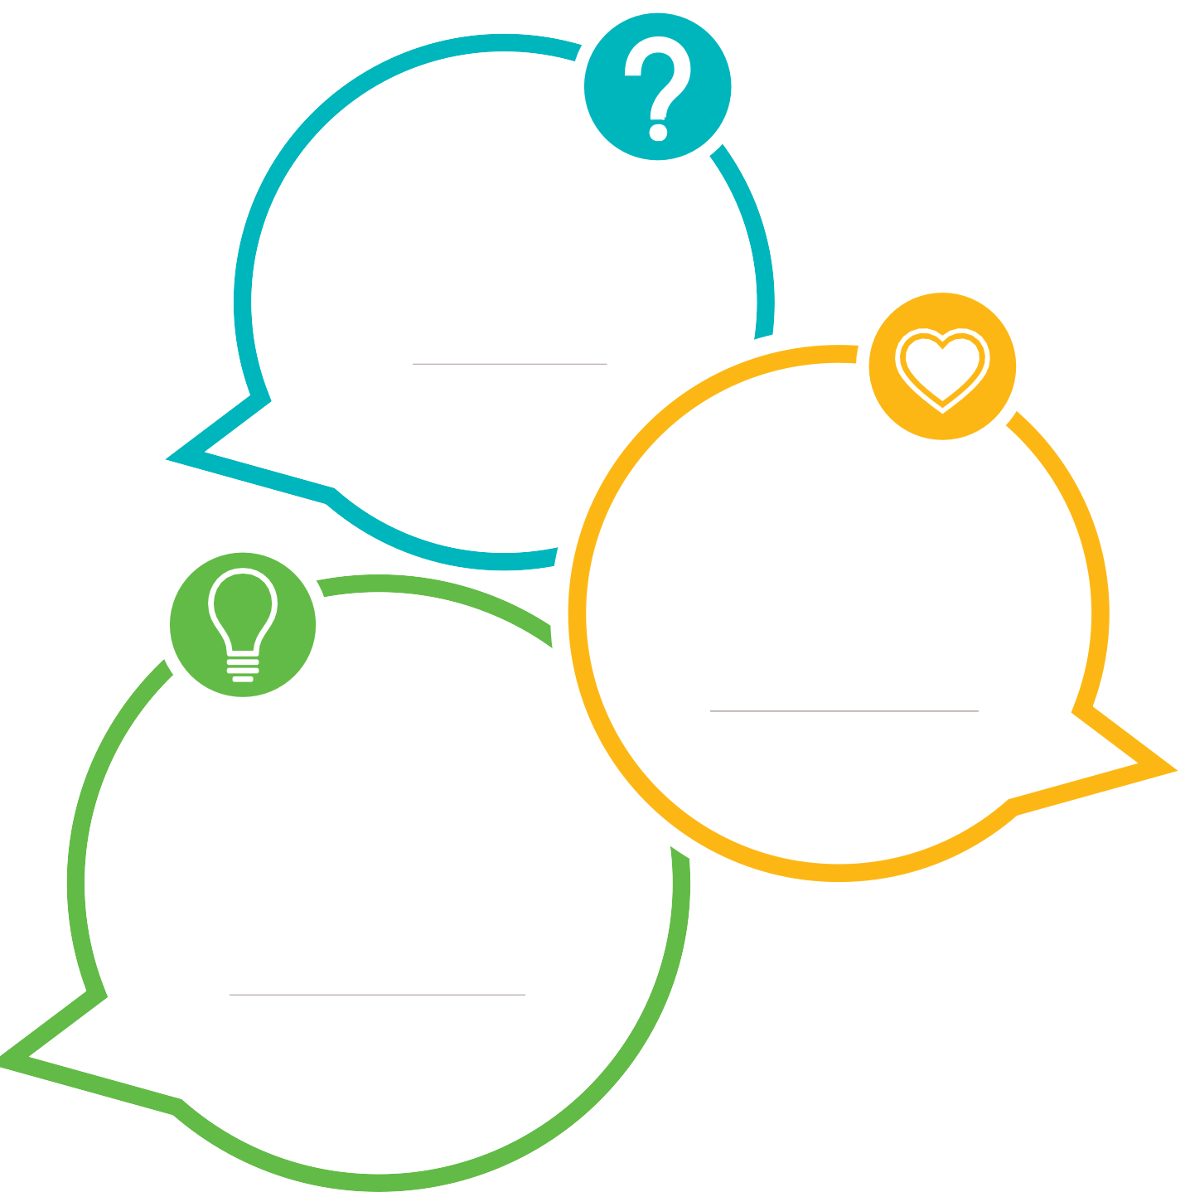

“What did you learn?”

**Asks children to evaluate**

**their skills.**

“What would you try differently

next time?”

**Encourages children to consider different approaches.**

“What are you most proud of?”

**Focuses attention**

**on emotions.**