### **CONVERSATION**

### **STARTERS**

### **babies**

while

DISCOVERING

together

“Look,

you just threw down your cup!””

**Acknowledges something without judgment.**



# “I wonder

# how you can reach your toy car.”

**Shows curiosity and a desire to learn more.**

“Tell me more.”   
Pause several seconds.   
Listen to baby’s babble.  
Hmmm . . . That’s interesting.

**Encourages baby   
to babble or communicate.**



while

**CONVERSATION**

**STARTERS**

**babies**

READING

together

“What’s this?”  
  
Following where baby is looking, point to an object in picture. Say the name of the object. Pause for baby to babble back.

**Helps baby understand and express new words.**

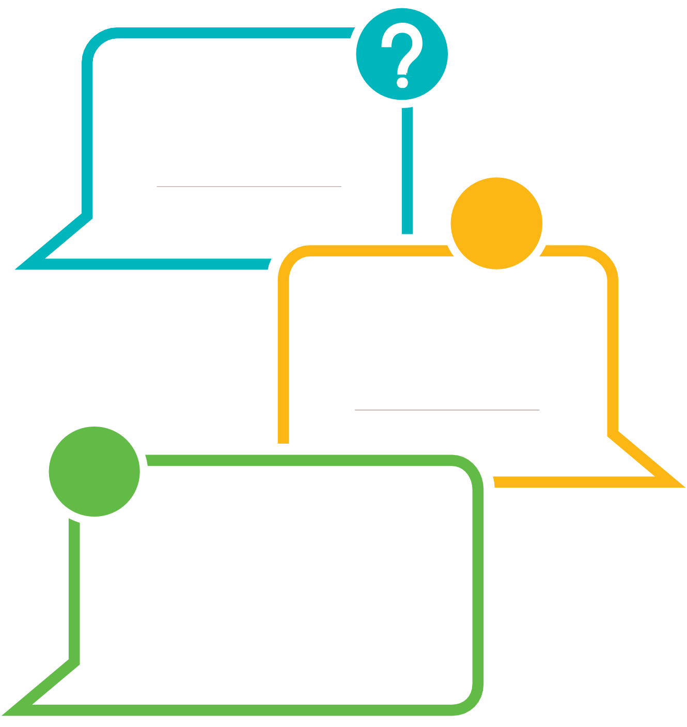

“How do you think this baby is feeling?

Point to picture of baby’s or characters’ face.

Pause. Offer a suggestion.

**Helps build empathy.**



“What do you think will happen next?”

“Look, here is a picture of a baby eating ice cream.” Pause. Add your ideas.

**Exposes baby to sequencing.**



**CONVERSATION STARTERS**

**babies**

while

PLAYING

together

“How are these two items

the same or different?”

Pause for baby to feel the items.

Allow time for baby to babble to you. Describe the items.

**Helps babies compare and contrast.**

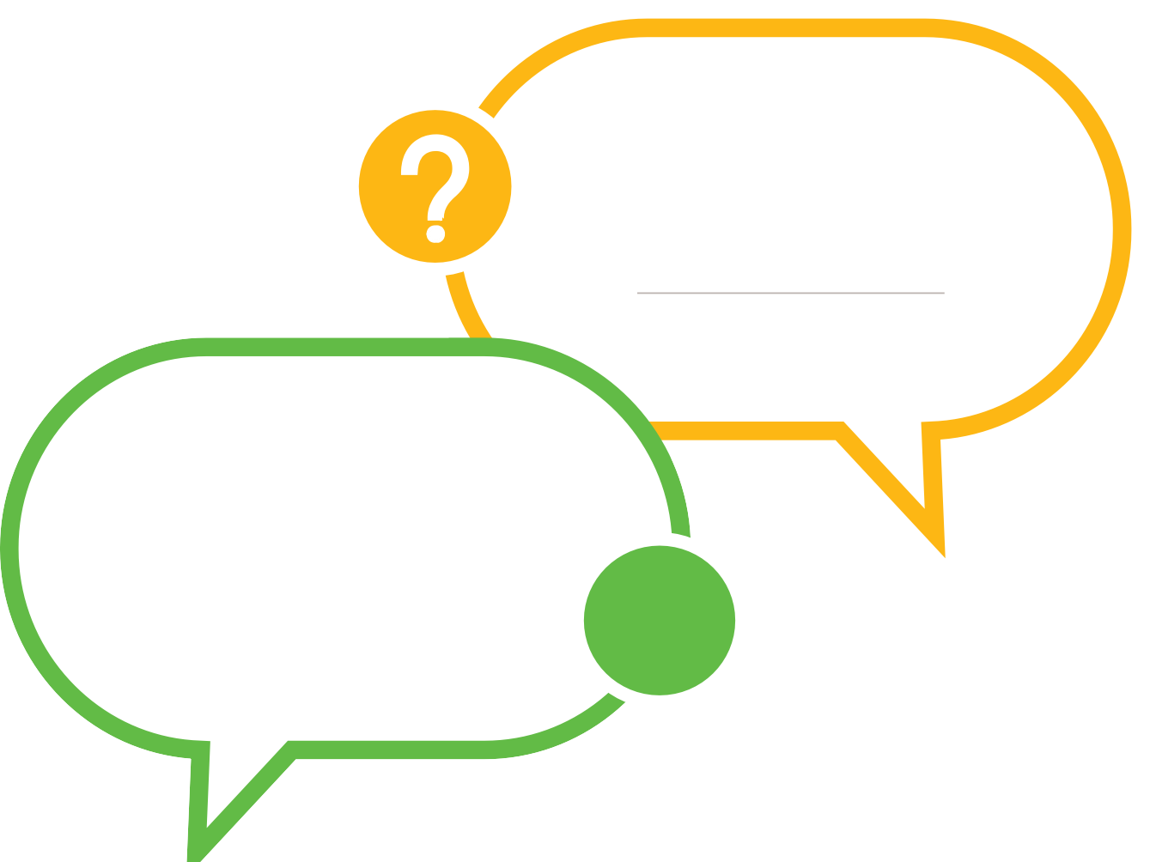

“What else can you do with that?”

“You’re using a spoon to hang on the pot.   
What else can you do with the spoon?

**Challenges babies to**

**think in new ways.**

“What can we do together?”

“Let’s play pat-a-cake together.”

**Encourages collaboration.**

while

**CONVERSATION STARTERS**

**babies**

EXPLORING

together

“Oh! Look at this!”

Let the baby hold the object.

Describe the object.

**Prompts children to**

**observe closely.**



“Let’s see what happens when

you drop this toy in the bath water.”

**Encourages children to consider**

**cause and effect.**

“I wonder what’s   
going on here.”

“This shoe doesn’t fit because   
it is made for the other foot.”

Share information.

**Provides babies with new information.**



REFLECTING

while

together

**CONVERSATION**

**STARTERS**

**BABIES**

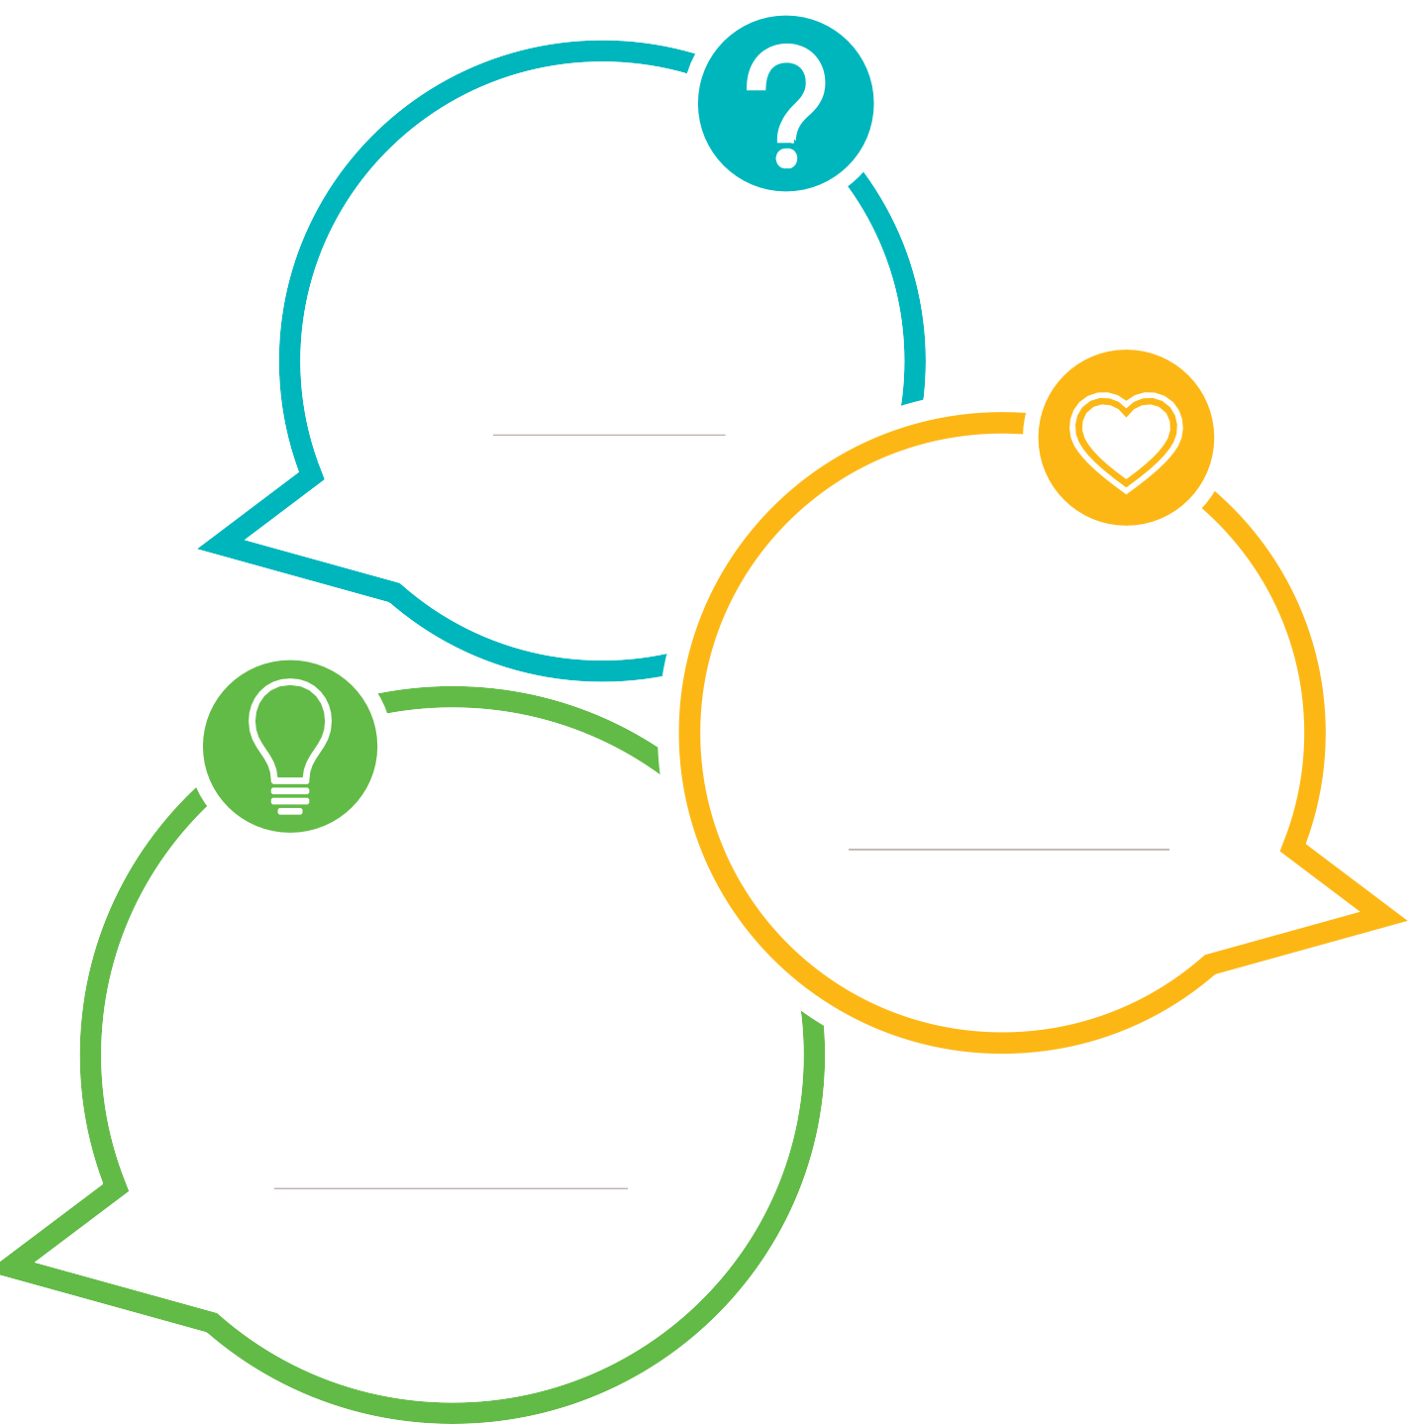

“Do you like how   
this tastes?”  
  
Watch baby’s expression as baby tries   
a new food.

Pause for baby to react.

Express what baby may be feeling.

**Asks baby’s opinion.**

“What else

can you do?”   
  
“You like to hold the ball.”   
See if the child does anything differently.   
If not, you might say, “Try rolling it.”

**Encourages children to**

**consider different options.**

“How are you feeling?”

From baby’s facial expressions and   
body language, use words to reflect   
how baby may be feeling.

**Focuses attention**

**on emotions.**